**AMAZON SQS – SIMPLE QUEUE SERVICE**

**What’s a queue?**

* Oldest Amazon offering (10 years old)
* Fully managed service (~serverless), use to **decouple** applications
* Scales from 1 message per sec to 10000s of messages per second
* Default retention of messages – 4 days, maximum 14 days
* No limit to how many messages can be in queue
* Messages are deleted **after** they are read by the customers
* Low latency
* Consumers share the work to read messages and scale horizontally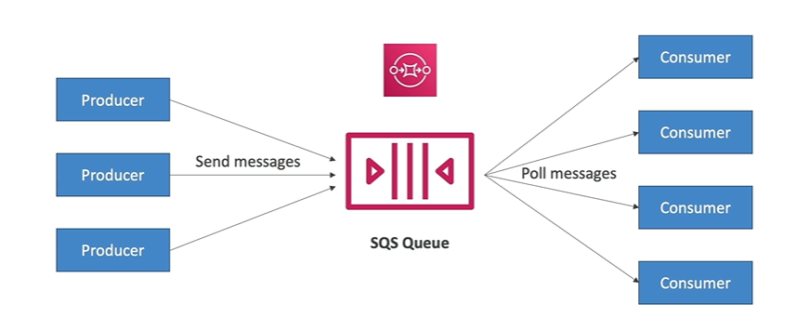

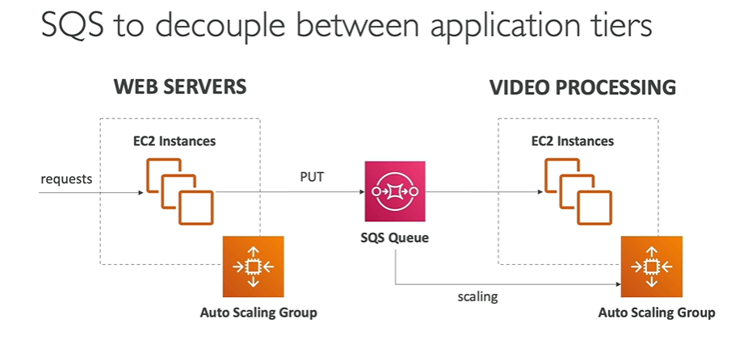

Web servers and video processing are fully decoupled. Both the ASGs can be scaled independently.

